Book Store Solution

This document contains the technical details about solution that integrates React 18 + Redux and .NET 10 Web API using PostgreSQL and Redis cache system to optimise performance focused on large applications.

Contents
Requirements 2
Overview 3
Scope 4
RQ-01 | Web API 5
RQ-02 | React Web App 6
RQ-03 | Redis 7
RQ-04 | PostgreSQL 8
RQ-05 | JWT Authentication 9
RQ-06 | Docker 10
RQ-07 | ALC 11
Annexes 12

Doc. Version | Date | Author | Description
2.0 | 2025-02-03 | https://github.com/kraftcoding | Second version of the release

Requirements
The next table shows the requirements for the solution described.
Requirement | Description
RQ-001 | Web API | Secured endpoints to authenticate and manage applications data
RQ-002 | React-Redux App | React based front-end integrating redux for data storage and persistence
RQ-003 | Redis | Server side in-memory storage system
RQ-004 | PostgreSQL | Data base
RQ-005 | JWT Authentication | Token bearer based authentication
RQ-006 | Docker | Containerisation ans deployment
RQ-006 | ALC | Application life-cycle definition

Overview
This document contains the technical details of the Book Store 2.0 full-stack solution, comprised of .Net 10 based Web API back-end, React 18 and Redux architecture based front-end application, PostgreSQL as database server, Redis for caching and in-memory data exchange to authorise and access to information and docker to deployment.
The next image the different elements the solutions comprised of and how they are distributed in the overall diagram.
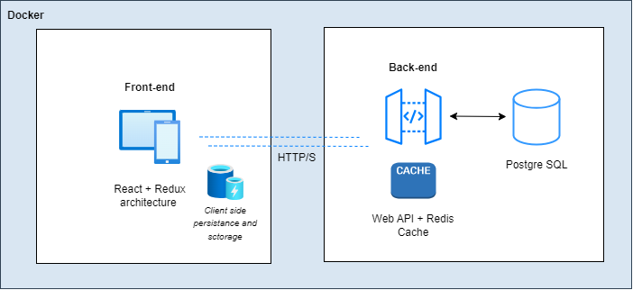
As we can see, the solution offers scalability and performance features by using Redux for client side persistence and storage together with server side cache with Redis. This is a key point to take in account for optimising performance in both sides especially when it comes to larger applications with big amount of data and fast response requirements.
User can access the application with the React based UI, being this fully responsive for diverse devices. The data requests goes through HTTP channels to server side using the cache to minimise database access.

Scope
The aim of this development is to offer a highly scalable and performance focused architecture as solution template for generic web applications to manage and store data by a responsive UI. Specifying application lice-cycle best practices for containerised deployments with Docker.

RQ-01 | Web API
The Web API is built with .NET 10 for a faster runtime and automatic memory pool eviction to reduce memory footprint in long-running applications minimising Garbage Collection (GC) overhead.
The project structure is the next one.
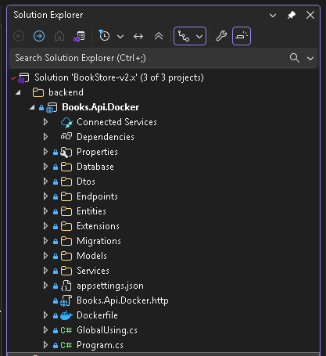
As we can see, it is designed by using clean architecture principles. The domain and application layer as the center of the design are the core of the project, being independent of the data access and infrastructure concerns. The Docker file contains the build and containerization instructions to assembly the image.
In the app-settings we will find the connection strings for local and dockerised environments, and JWT configuration. Is uses Swagger to get the API definition and schema together with a UI to test the endpoints.
Implement a cache system through Redis to optimize response times and resources by minimizing queries on the data base.

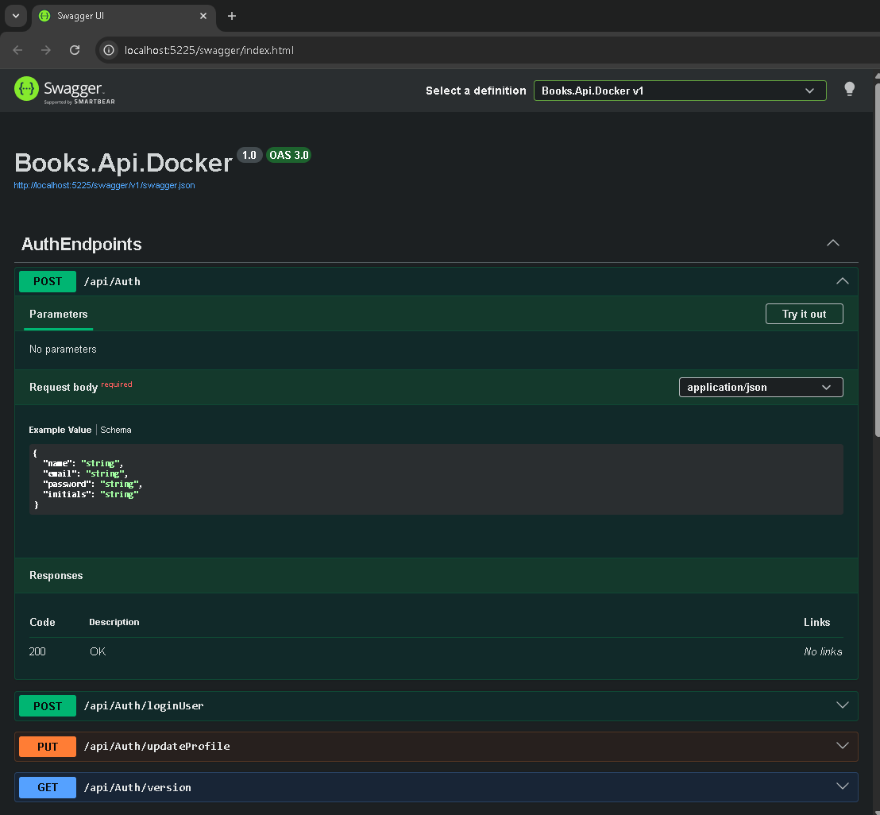

RQ-02 | React Web App
The front-end is built with React-Redux for a better performance and scalability.
Developing with React, is more about the architecture than the actual view being comprised of other parts that wire things up to that view. There are a lot of parts there, but each plays a very specific purpose.
Next diagram shows the parts by which de applications is comprised of and their relationship.
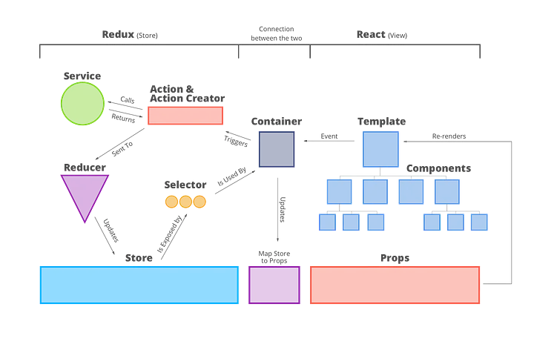
As we can see Services, Actions & Action Creators, Reducers, and Selectors are Redux. Templates and Components are react. The Container is piece that allows them to be loosely coupled together. It allows the store and the view to be able to change and grow independently of each other.
In this kind of architecture the state is in the store for Redux, and in the props for React. When the store is updated it re-maps through the container and re-renders the DOM. When there is an event in the DOM that triggers events through the container and to the Actions. The biggest thing to know here is that the store is where redux stores the data, the data is mapped to props, where React displays through components. And all that is state.

Parts and connections
- Component: The component is rendered with a set of props that get passed down from it’s parent component.

Template: Special kind of component that does things more specifically than the lower components do
- Container: The container is the glue that connects react to redux. It connects it in a lot of ways.
- Actions: This is an object that contains the type of action and the state that was changed because of the action.
- Reducers: For every dispatch every reducer is called and given the dispatched action. Then it is up to the reducer to handle it or pass it on.
- Selector: The selector is how you would get data out of your store in the container.

UI Screens
Next we are going to have a look to the different screens of the application.

RQ-03 | Redis
Requirement description...

RQ-04 | PostgreSQL
Requirement description...

RQ-05 | JWT Authentication
Requirement description...

RQ-06 | Docker
Requirement description...

RQ-07 | ALC
Requirement description...

Annexes
Annexes go here...

